Wrapper class program
Date:06/09/23
Autoboxing

- // java program to convert primitive into objects
// autoboxing example of int to Integer
public class WrapperExample1{
public static void main(String args[]){
// converting int into Integer
int a=20;
Integer i=Integer.valueOf(a);
Integer j=a;
System.out.println(a+" "+i+" "+j);
}
}
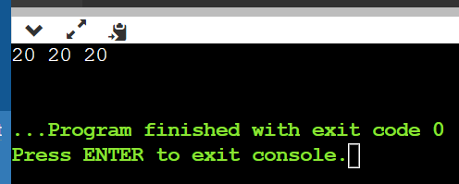

Unboxing

//java program to convery object into primitives
// unboxing example of integer to integer
public class WrapperExample2{
public static void main(String args[]){
//converting integer to integer
Integer a= new Integer(3);
int i=a.intValue();
int j=a;
System.out.println(a+" "+i+" "+j);
}
}
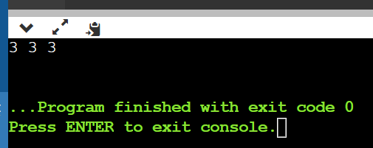
Over writing two string method
class Student {
int rollno;
String name;
String city;

Student(int rollno,String name,String city){
this.rollno=rollno;
this.name=name;
this.city=city;
}
public static void main(String args[]){
Student s1=new Student(101,"raj","Indore");
Student s2=new Student(102,"raju","Lacknow");
System.out.println(s1);
System.out.println(s2);
}
}
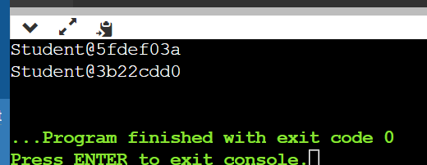
toString method
class Student {
int rollno;
String name;
String city;

Student(int rollno,String name,String city){
this.rollno=rollno;
this.name=name;
this.city=city;
}
public String toString()
{
return rollno + name + city;
}
public static void main(String args[]){
Student s1=new Student(101,"raj","Indore");
Student s2=new Student(102,"raju","Lacknow");
System.out.println(s1);
System.out.println(s2);
}
}
